INTRODUCTION
TO THE

MOTOROLA
C-QUAM®
AM STEREO
SYSTEM





C-QUAM® IS A REGISTERED © MOTOROLA INC. 1992
TRADEMARK OF MOTOROLA, INC.

INTRODUCTION

For many years, scientists and engineers have attempted to find ways of transmitting and receiving more information while using less bandwidth. The AM stereo system is a good example of just that, multiplexing another channel along with an existing one in order to transmit additional information.

Communication systems can be mathematically modeled, including factors such as transmitted signal, channel bandwidth, signal to noise levels, distortion, crosstalk and other parameters. Motorola has devoted a considerable effort in its research and development in many areas of communication theory, including a corporate research section called the Modulation Systems Laboratory. There, an ongoing program continually seeks out ways of improving transmission efficiency and the results of this research can be applied to many communication systems, including broadcasting.

Motorola's C-QUAM® AM stereo was originally conceived as a mathematical model of a new technology communication system by the corporate research and development staff, and its worth was proven by computer analysis before anyone touched a soldering iron.

Nearly seven years passed between the original concept of Motorola's AM stereo system and the development of production hardware. Motorola corporate staff scientist, and the Modulation Systems Laboratory, began work on the technology in 1975. The basic system theory was developed in about four months, but refinements and FCC approval required an additional five years. Four other corporations competed for AM stereo system approval. However, the FCC left it up to the industry marketplace which included broadcasters, receiver manufacturers, and system proponents to resolve a system standard.

The idea of AM stereo is not new. Philco developed an experimental AM stereo system in the late fifties using quadrature modulation and tested it on WABC in New York. Also, CBS, in the early sixties, tried out a very similar system and conducted experimental transmission on WCBS also in New York.

Philco did propose its system to the FCC in the AM-FM and TV stereo proceedings in the late fifties, but the Commission rejected all AM stereo Systems at that time. CBS did not pursue its system further. Concurrently, the FCC in the 1960s granted stereo capabilities only to FM radio, which was having difficulty competing with AM radio at that time. But AM radio soon began to lose ground without stereo sound. AM converted to talk because it didn't have stereo, and continued to lose market share for many years.

While Philco and CBS had been unsuccessful in implementing a compatible quadrature system, Motorola found a way to take advantage of the quadrature characteristics while still maintaining monaural compatibility. The Motorola system extracts the phase modulation component of a full quadrature signal and transmits that as the stereo information. The monaural signal is transmitted as the normal AM signal thus providing excellent compatibility with AM receivers.

The resulting Motorola C-QUAM® system consists of - an exciter that converts AM transmitters to stereo and a monitor that measures the results - which are both installed at the AM radio station.

The final system link is the radio receiver (introduced in 1983) incorporating the Motorola MCI-3020 C-QUAM® AM stereo decoder integrated circuit.

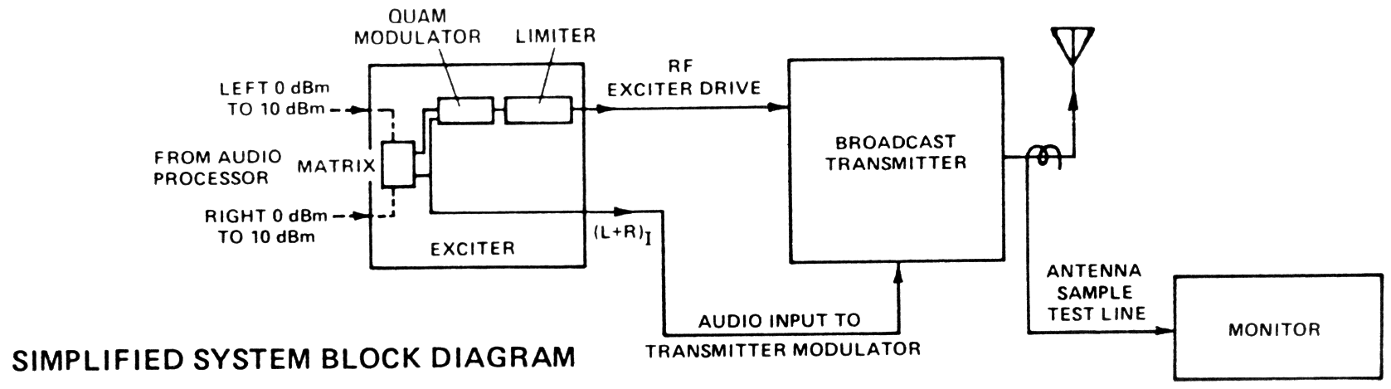
WHAT IS C-QUAM®?

C-QUAM® is a system using amplitude modulation for the main (L + R) signal, and a quadrature type of phase modulation for the stereo information. Quadrature combines two signals at a phase angle of 90 degrees for transmission, and then at the receiver separates them again. It is another form of multiplexing. This technique is used to transmit the color information in the U.S. TV color system and is used for encoding of SQ and QS quadraphonic records. In the application to AM stereo, quadrature is really transmitting two AM signals on the same channel. For relatively narrow bandwidth applications such as we have with AM radio, AM is really the most efficient emission be-cause amplitude modulaton requires the minimum bandwidth and it is independent of noise. What this means is that in an AM receiver, the effective background noise remains the same with or without modulation. This is not so with FM or PM, which under modulation, “kicks up” additional noise not present under no modulation conditions. So in AM quadrature, an additional channel can be created and heavily modulated without “kicking up” excessive noise. In other words, for narrow bandwidth communications systems, there is a signal to noise advantage to using AM quadrature.

Another important point for AM stereo is the long transmission path from the transmitter, through a directional antenna, over a difficult propagation path, and through a narrow bandwidth and possibly mistuned receiver; is a very rough one. In order to be demodulated with the least distortion and maintaining separation, the signal must be very resilient ... able to withstand the difficult transmission experience. This also is best done with AM quadrature because two of the same type of signals are being transmitted and therefore undergo the same type of distortions which can in many instances be canceled at the other end. In other words, for AM stereo the differences between the two signals must be preserved, and if each undergoes the identical distortions during transmission, the differences between the two signals will be maintained. This is another reason why the AM/PM and AM/FM stereo systems are not very good because distortions to the AM component are very different from the distortions to the PM or FM component during transmission, and the result is a much more distorted AM stereo signal.

Although many have tried to use AM quadrature for AM stereo~the most difficulty is encoun-tered when modifications are made to make it compatible w,th envelope detectors in existing AM radios. The Motorola scientists and engineers found a way of taking advantage of the quadrature characteristics, while transmitting a compatible AM component.

THE NATURE OF AM AND FM SIDEBANDS

In order to describe the system, some basics must be understood about certain types of modu-lation and how it is detected or not detected. To check our understanding, let's look at two basic types of transmission, AM and FM, modulated by a very low distortion sine wave.

When a signal is amplitude modulated by a sine wave, we can describe it in several ways. One is to simply look at the amplitude and trace it vs. time. This would be the typical display on an oscilloscope of the R.F. envelope. See Figure 1. Another is to look at it on a spectrum analyzer which would show three vertical lines, in the center, a taller line representing the carrier, and the two sidebands, lesser in amplitude, shown on either side of the carrier. In these two representations, there is no phase information given but for now think of the two sidebands as being in-phase sidebands or “I” sidebands. Thus in a perfect AM signal with no distortion there are no higher order sidebands or harmonics of the primary AM sidebands and there is no net phase modulation of the total of the carrier and the two sidebands.

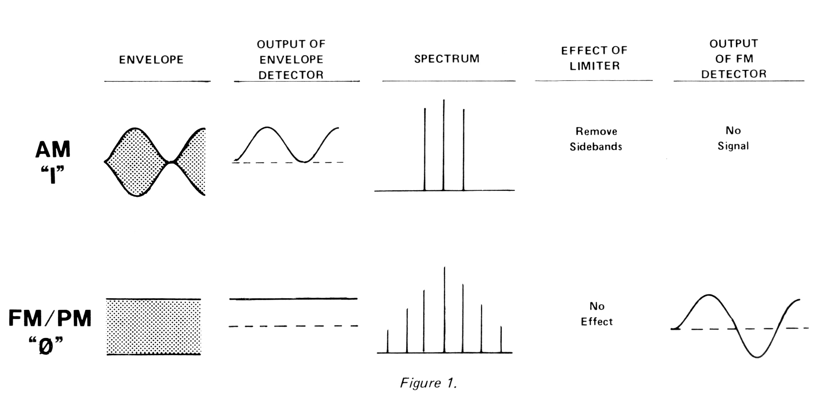
The other case, FM (or PM) is where the phase or frequency is modulated according to our low distortion sine wave, and let's say the deviation is at least a few kHz. In this case, the R.F. envelope does not vary and the A.C. output of the envelope detector would be zero. The spectrum, however, would usually consist of a component at the carrier frequency and a family of sidebands located at multiples of the modulating frequency away from the carrier. For instance if the carrier frequency was 1000 kHz, and the modulation was 1 kHz, there would be symmetrical sidebands at 999, 1001 and at multiples of 1 kHz that are significant.

If there is a carrier and sidebands, why doesn't the envelope detector detect the modulation? The reason is that in FM and PM, the instantaneous phase and amplitude of the carrier Component and all the sidebands always add up to the same power as the unmodulated carrier. As the modulation is turned up, the carrier is reduced in amplitude and the missing carrier power is given to the sidebands, but the sum total at all times remains the same. It is the phasing of the sidebands that determines whether they will add and subtract with the carrier to produce differences in amplitude or whether they will add and subtract with the carrier component to always give the same amplitude. In the case of FM or PM, let's call the sidebands phase or “Ø” (phi) sidebands.

Now, the interesting thing is that “Ø” sidebands don't need a linear amplifier to be amplified and can be crunched to death by limiters and class C amplifiers and the same spectrum still comes out the other end. On the other hand “I” sidebands must have linear amplification in order to survive and can be totally stripped from the signal by a good limiter. An envelope detector will be blind to the existence of perfect PM or FM sidebands, and a phase or frequency demodulator will not see perfect “I” sidebands or amplitude modulation.

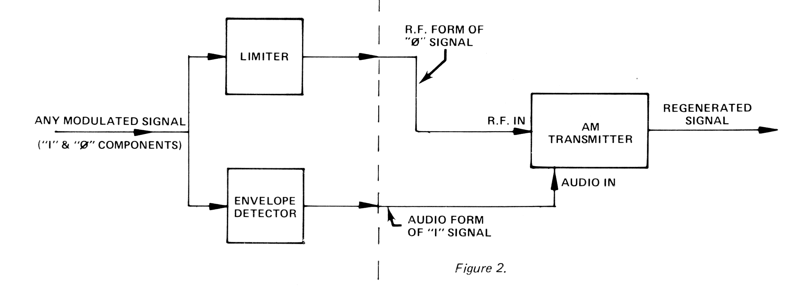
Another interesting fact is that all modulation can be represented by a combination of the “I” sideband components and the “Ø” sideband components. This is very important in AM stereo broadcasting because it is necessary to split any of the AM stereo system's signals into the “I” and “Ø” signals for transmission on an existing AM transmitter. See Figure 2. For all systems, the “I” signal is given to the transmitter in audio form at the audio input to the transmitter and then it amplitude modulates the signal in the normal way recreating an AM or an “I” sideband signal. For all systems, the “Ø” components are fed to the transmitter in R.F. form as a phase modulated signal that replaces the crystal oscillator in the transmitter. Of course the “Ø” signal sidebands can pass through the intermediate and final amplifier R.F. stages of the transmitter even though these stages are non linear and usually operate class C. The Motorola AM stereo system also required that it be reconstructed for such transmission but certain modifications are made for compatibility with the millions of existing AM radios.

PURE QUADRATURE

Observe Figure 3. Pure AM-AM quadrature can be generated by two transmitters connected so that their outputs add. One transmitter would be a standard AM generator producing the carrier at, let's say, zero phase, and sidebands associated with that carrier (“I” sidebands). A second transmitter is fed from the same master oscillator as the AM transmitter, but the phase is shifted 90 degrees. Because we already have a full carrier at zero degrees phase from the AM transmitter provIding a phase reference for the receiver, the second transmitter does not need a carrier and is set up with a balanced modulator canceling out the carrier and producing only sidebands. Because these sidebands are generated from a carrier which is 90 degrees out of phase from the AM transmitter, these sidebands will be 90 degrees out of phase with the AM sidebands and “in quadrature.” These become our “Q” sidebands.
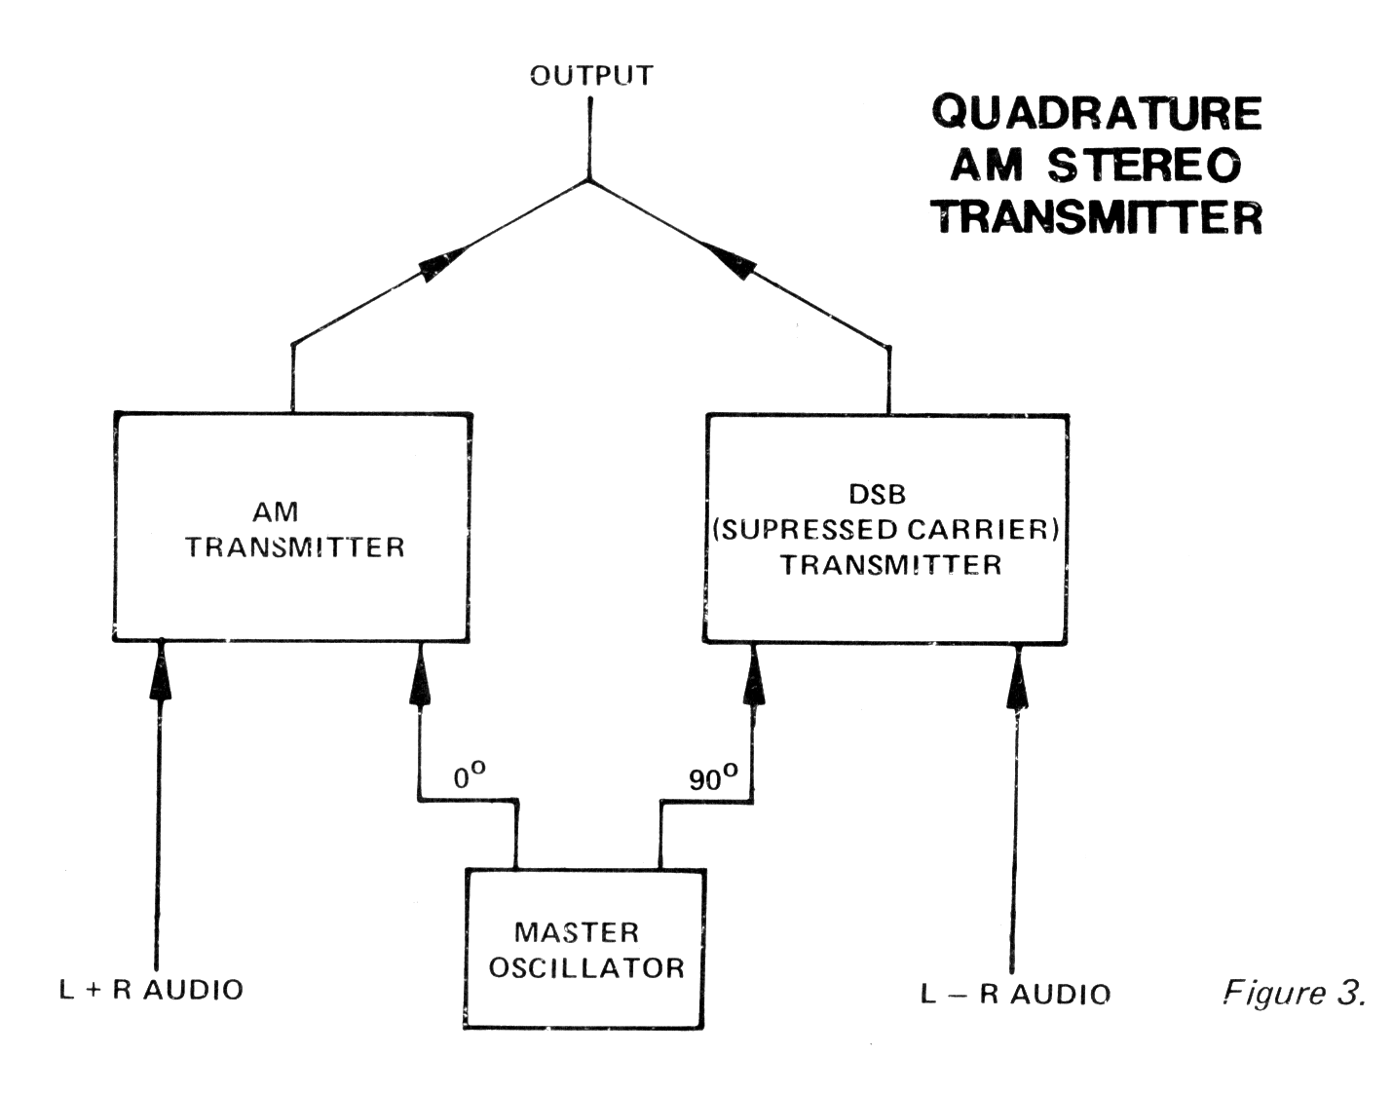

If we wanted to make an AM stereo system we could transmit L + R into the AM transmitter, and L - R into the double sideband transmitter. Sounds good, but under left or right only conditions where both transmitters are contributing sidebands to the output, the resultant would be a distorted AM signal. Before we look at why, let's take a look at a quadrature demodulator which is also the widely touted synchronous detector.

THE QUADRATURE (SYNCHRONOUS) DETECTOR

To recover the audio signals separately at the receiver, a system of phase detectors is arranged. See Figure 4. First, a reference phase must be derived from the transmitted signal. This is the refe-ence carrier which is generated by means of a phase locked loop (PLL).

The device that is primarily responsible for the operation of the synchronous detector is the balanced demodulator or product detector. When this device is given an input signal and a reference carrier, it will provide at its Output the difference of the two signals. If the two signals are identical in frequency and 90 degrees Out of phase, the output will be zero. If there is a constant difference in phase it will give a D.C. output or if the phase is varying it will give an A.C. output. The D.C. output of the “Q” detector is fed back to a voltage controlled oscillator (VCO) which causes the frequency and phase of that oscillator to zero in on the input carrier frequency and phase and then lock to it.

This provides the phase reference for the “I” and “Q” detectors. The A.C. output from the “I” demodulator provides the original L + R audio from the AM transmitter, but it does not see the “Q” sidebands from the double sideband transmitter. The second demodulator is also fed from the VCO but its carrier reference signal is automatically shifted 90 degrees. Therefore it sees the “Q” sidebands from the double sideband transmitter and sees nothing from the AM transmitter input audio which is L + R.

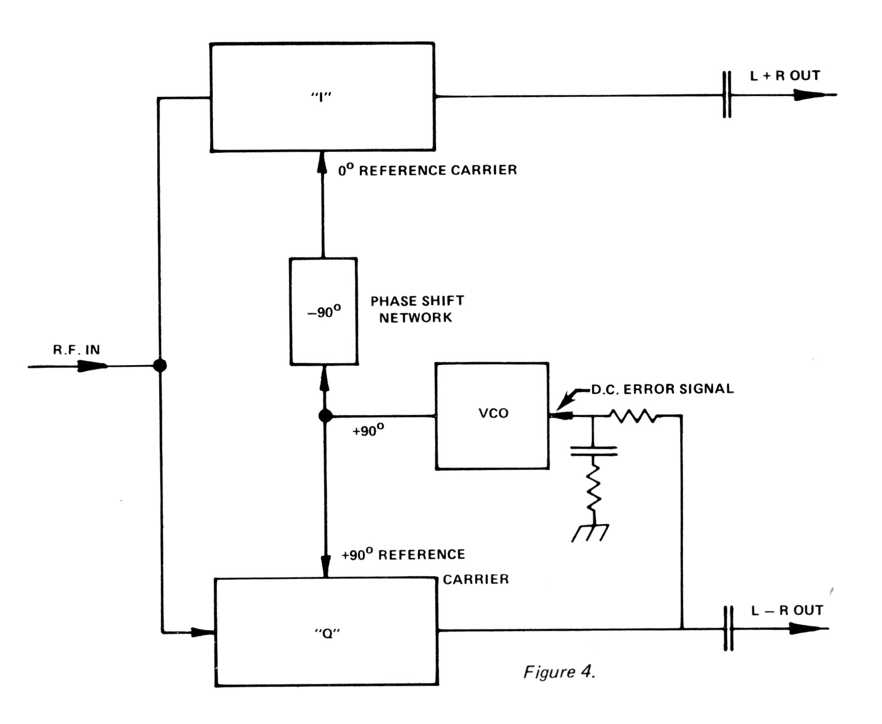

The AM-AM quadrature system would be excellent for AM stereo except that the envelope detectors in normal AM radios don't see only the “I” sidebands or the “0” sidebands but see the simple vector addition of both. The envelope detector is not capable of seeing any phase information and only sees the RMS total of the modulation and carrier regardless of phase.

Under L + R (L R) only modulation conditions (monaural), there is no problem, because only the AM transmitter is modulated and the envelope detector recovers AM perfectly. (The double sideband Stereo transmitter receives no audio because when L = R, L - R = 0.) However, under stereo conditions, for instance, when L only is transmitted, full sideband components are contributed by both the AM and double sideband transmitters and the envelope looks like Figure 5. This would not be compatible with existing envelope detector receivers and a very distorted signal would be heard.
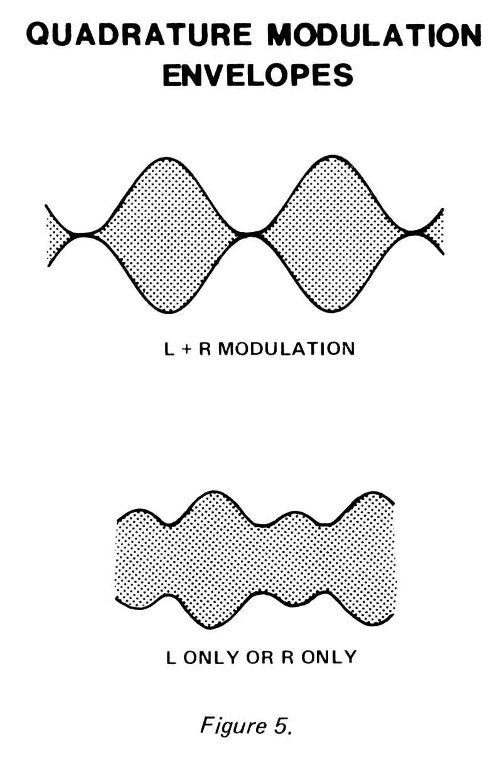

COMPATIBLE QUADRATURE

The Motorola AM stereo system is not complicated at all. It simply takes a pure quadrature signal as just described, and extracts the phase modulation components of the quadrature signal and phase modulated the broadcast transmitter. At the same time it sends L + R audio to the audio input of the transmitter as usual. That's it! The advantage is that a very nice AM signal is always trans-mitted so that the envelope detectors are compatible, but that the phase modulation of the carrier is derived from a pure quadrature modulation. The result is a signal with most of the advantages of quadrature modulation while maintaining all important monaural compatibility.

THE C-QUAM® ENCODER

The C-QUAM® encoder is diagramed in Figure 6. Note that pure quadrature is generated by taking L + R and L - R and modulating two balanced modulators fed with R.F. signals out of phase by 90 degrees. In this case the 90 degrees phase shift is derived by using a Johnson counter which divides an input frequency (four times station carrier frequency) by four and automatically provides digital signals precisely 90 degrees out of phase for the balanced modulators. The carrier is inserted directly from the Johnson counter. At the output of the summing network, the result is a pure quadrature AM stereo signal. From there it is passed through a limiter which strips the incompatible AM components from the signal and leaves only the phase modulation “Ø” sidebands. This is not the same as the simple output of the “Q” modulator because the addition of the “I” and “Q” balanced modulators produced some phase shifting not present in the “Q” modulator alone. The output of the limiter is amplified and sent to the broadcast transmitter in place of the crystal oscillator.

The left and right audio signals are precisely added and sent to the audio input terminals of the broadcast transmitter.

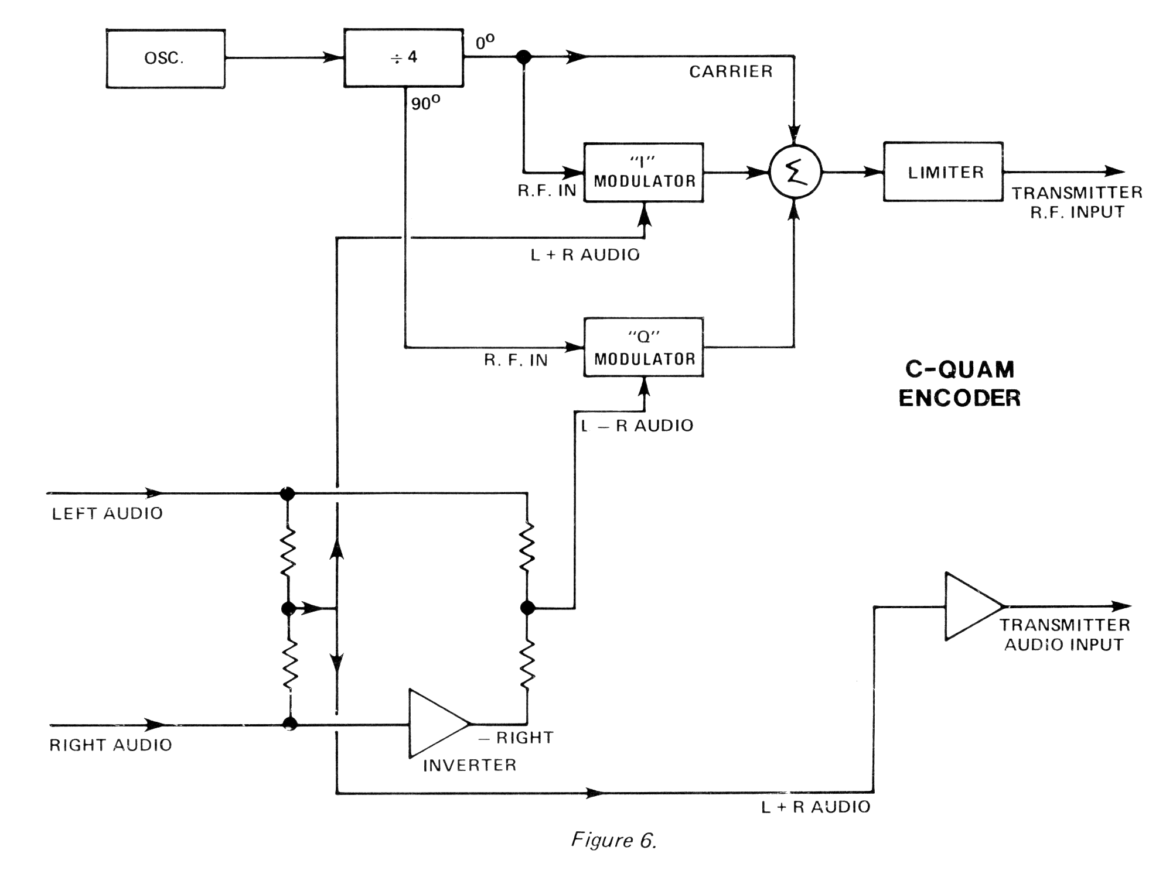
That's the essence of the Motorola C-QUAM® encoder.

DECODING C-QUAM®

C-QUAM® is decoded by simply converting the broadcast signal which is already “almost” quadrature to quadrature and then using a quadrature detector to extract L - R. Refer to Figure 7. Note that the demodulator contains a section which is the pure quadrature demodulator as previously described. In order to prepare the broadcast signal for the quadrature demodulator, it has to be converted from the envelope detector compatible signal which is broadcast, to the original quadrature

signal that was not envelope detector compatible. This is done by demodulating the broadcast signal two ways; with an envelope detector, and with an “I” detector. The two signals are compared and the resultant error signal is used to gain modulate the input of the “I” and “Q” demodulators.

When the transmitted signal is L + R (monaural, no stereo) the transmitted signal is pure AM or only “I” sidebands. In this case the envelope detector and the “I” demodulator see the same thing. There is no error signal, the gain modulator does nothing and the signal passes through without change. However, when a left or right only signal is transmitted, both AM and PM is transmitted and the input signal is shifted in phase to the “I” demodulator and loses some of its “I” amplitude. The envelope detector sees no difference in the AM because of the phase modulation, and when the envelope detector and the “I” demodulator are compared, there is an error signal. The error signal AGC's the input level to the detector. This action makes the input signal to the “I” and “Q” demodulators look like a pure quadrature signal and the “Q” audio output gives a perfect L R signal. The demodulator output is combined with the envelope detector output in a matrix to give left and right audio outputs.
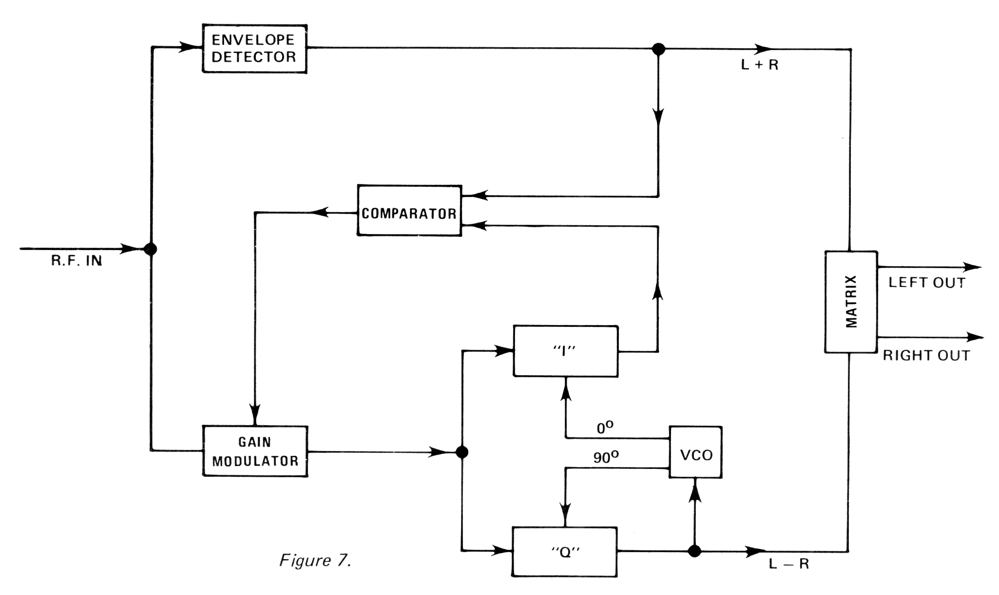

SYSTEM PERFORMANCE UNDER HEAVY MODULATION

There are many advantages of the Motorola system. One is its performance under 100 percent negative amplitude modulation conditions. When the carrier momentarily becomes small as in 100 percent negative modulation, the output of the envelope detector also becomes small. Because of the action of the comparator and gain modulator, the output of the “I” demodulator is small. Simultaneously, the output of the “Q” demodulator also is forced to be small. This means that there will be no large noise popping from the stereo channel under heavy negative amplitude modulations.

APPENDIX

The following is a more detailed mathematical description of the C-QUAM® system.

ENCODING COMPATIBLE QUADRATURE MODULATION

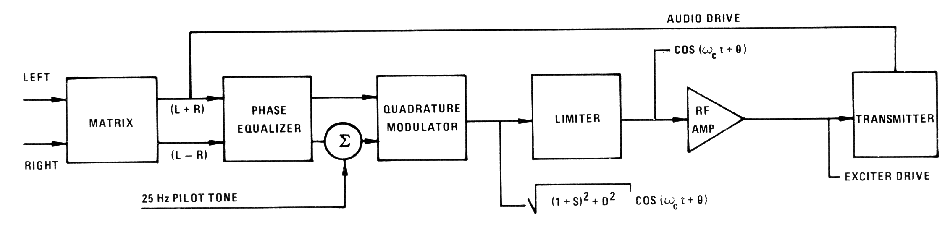
The existing RF oscillator of the transmitter is replaced by a substitute reference which has the angular modulation of a quadrature signal. The existing AM modulation technique is basically unchanged.

Note that the audio modulation sum information is unchanged from the monaural case and that a quadrature phase modulated RF drive is substituted for normal RF drive. The only other change is the presence of a Phase Equalizer to compensate for the differences in Amplitude/Phase relationships between the audio signal path and the RF path. This is necessary to maintain separation over a wide bandwidth.

Any suitable stereophonic audio processors may be used.

DECODING THE COMPATIBLE QUADRATURE SIGNAL

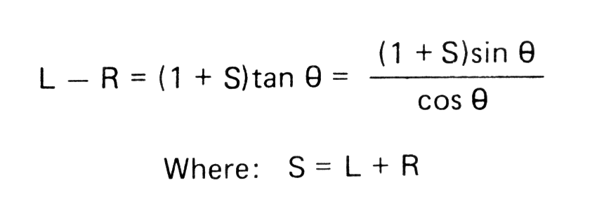
The received compatible quadrature signal is a quadrature signal which has been modulated by the cosine of its relative phase angle information. It is also a compatible envelope detector signal. Therefore, sum information may be decoded with either an envelope detector or with a synchronous detector that is inversely modulated by the cosine of the phase modulat~on. Difference information may be decoded with a synchronous quadrature demodulator which is in inversely modulated by the cosine of the phase modulation. In fact, there exists a multiplicity of decoding methods since:

Hence, any sequence of Operations which results in L - R is a valid decoding algorithm. Even non-PLL decoders are allowed since a discriminator, integrator, tangent function sequence results in L-R.

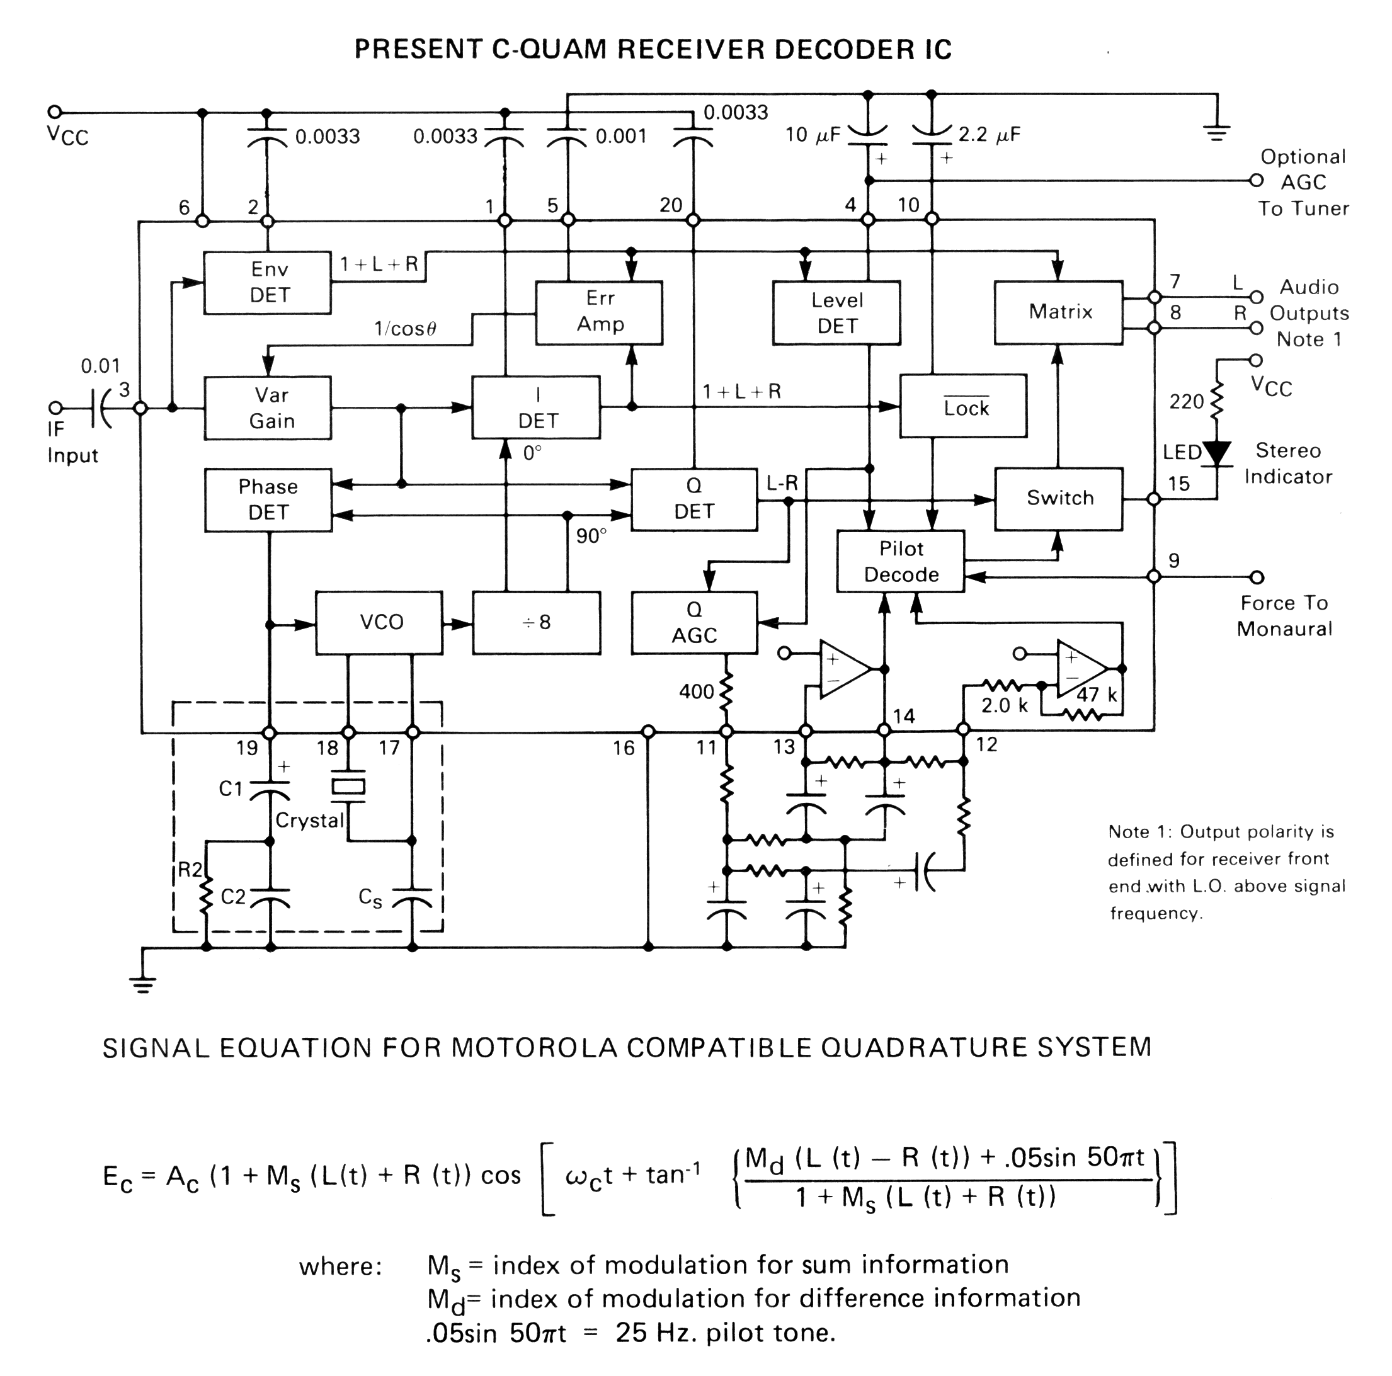
Motorola has evolved a first generation decoder design already discussed, which maximizes performance benefits at a minimum of cost and adjustments. Second and third generation decoders are under development which will further advance the state of the art.

MOTOROLA AM STEREO TELEX NUMBERS
3701 W. Algonquin Road, 6th Floor TTY: 28-2562
Rolling Meadows, IL 60008-3120 -or-
Phone: 708/576-3592 4330355
FAX: 708/576-5479 TWX: 910-693-4078

0292

